# Compass MED D - View Medicare Prescription Payment Plan Tab

Medicare Prescription Payment Plan Tab

M3P Tab with Expanded Services

M3P Tab with No Expanded Services

Quick Actions Panel

Summary Tab

Opt In/Opt Out Tab

Opt In Request Type

Opt Out Request Type

Opt In/Opt Out History Tab

Payment Schedule & Forecast Tab

Payment History Tab

Claims History Tab

Related Documents

**Description:** This document outlines the Medicare Prescription Payment Plan tab and functionality found in Compass.

****CMS has provided guidance that the Medicare Prescription Payment Plan should NOT be abbreviated when speaking to members about the program. The program may be referred to as M3P or MPPP in the Compass system, but these acronyms should NOT be used with members.

|  |
| --- |
| Medicare Prescription Payment Plan Tab |

The **M3P** tab is accessed by clicking the **Medicare Prescription Payment Plan (M3P)** hyperlink in the **Quick Actions** panel on the Member Snapshot Landing Page.

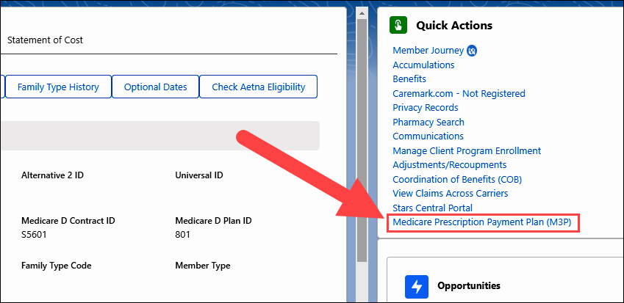

**Result:** The **M3P** tab will open on the **Summary** tab. Other sub-tabs will be available depending on whether or not the plan has Expanded Services.

### M3P Tab with Expanded Services

In the **Caremark Service Type** field, the **Expanded Services** information icon () displays the following message: “The member’s health plan has delegated Caremark to address all inquiries related to the Medicare Prescription Payment Plan (M3P).”

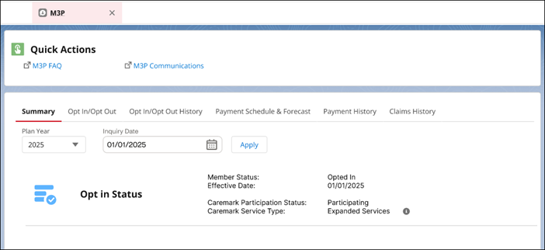

### M3P Tab with No Expanded Services

In the **Caremark Service Type** field, the **No Expanded Services** information icon () displays the following message: “General program questions and claim inquires can be answered by CVS Caremark. For instruction on additional call types, refer to the CIF for client specific information.”

**Note:** Prior to the program rollout and in some screenshots, “No Expanded Services” may appear as “Core” or “No Enhanced Services”.

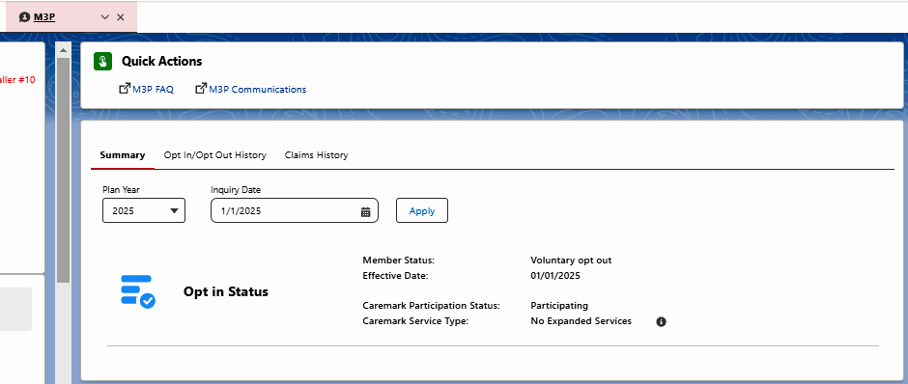

Top of the Document

|  |
| --- |
| Quick Actions Panel |

The Quick Actions panel on the **M3P** tab contains the following links:



|  |  |
| --- | --- |
| **Section / Field** | **Details** |
| **M3P FAQ** | Reference [Compass MED D – Medicare Prescription Payment Plan Guidelines](https://thesource.cvshealth.com/nuxeo/thesource/#!/view?docid=54f362a8-c10b-43c3-b4dd-124af1173532) for frequently asked questions. |
| **M3P Communications** | Reference material for all MED D Communications pertaining to M3P (ONEclick). |

Top of the Document

|  |
| --- |
| Summary Tab |

Refer to the table below for information regarding the sections and fields on the **Summary** tab.

**Note:** The **Summary** tab displays the **Payments** and **Current Invoice** sections shown below only when the Caremark Service Type is “Expanded Services”:

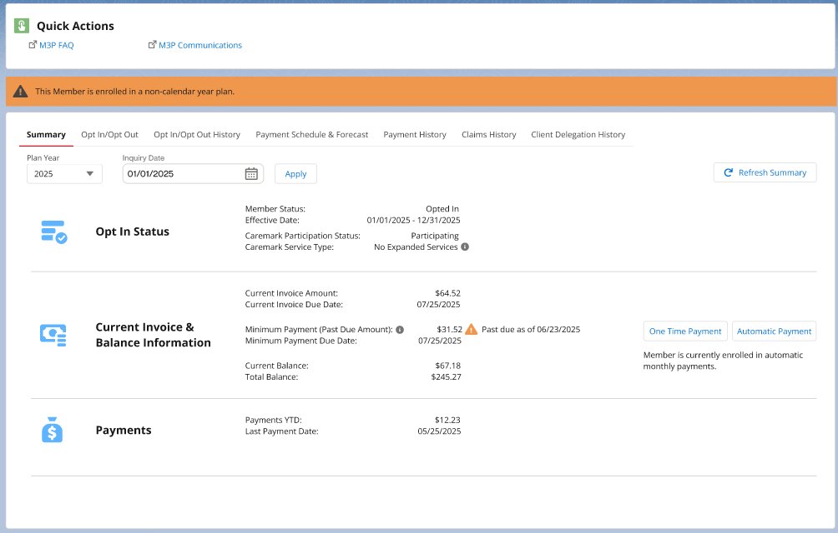

|  |  |
| --- | --- |
| **Section / Field** | **Details** |
| **Plan Year** | * Displays Plan Year drop-down menu. |
| **Inquiry Date** | * Displays Inquiry Date with calendar icon to select the date. |
| **Apply Button** | * Click the **Apply** button after changing the default **Plan Year** and **Inquiry Date** selections. |
| **Refresh Summary Button** | * Refreshes the following sections on the Summary sub-tab:   + Opt In Status   + Current Invoice   + Payments |
| **Opt in Status** | * **Member Status:** Displays one of the following options: Not Participating, Opted In, Voluntarily Opted Out or Involuntarily Opted Out. * **Effective Date:** Date when Opt In or Opt Out is effective. * **Caremark Participation Status:**    + **Participating:** Client has delegated CVS Caremark to provide Medicare Prescription Payment Plan services.   + **Not Participating:** Not participating could mean the client is on a non-calendar year plan and they have a future participation date OR this is a $0 copay plan. Refer to the CIF for client specific information. * **Caremark Service Type:**    + **No Expanded Services:** Client has contracted with CVS Caremark to provide claims processing management, customer care, reporting to perform program calculations, and pharmacy messaging.   + **Expanded Services:** Medicare Prescription Payment Plan program participation management, accounts receivable status reporting, increased Customer Care capabilities, and member communications. |
| **Current Invoice and Balance**  **(Expanded Services only)** | * **Current Invoice Amount:** Current dollar ($) amount due for the Medicare Prescription Payment Plan. * **Current Invoice Due Date:** Current due date for next payment for the Medicare Prescription Payment Plan. * **Minimum Payment (Past Due Amount):** Current dollar ($) amount past due for the Medicare Prescription Payment Plan. * **Minimum Payment Due Date:** Due date for past due payment for the Medicare Prescription Payment Plan. * **Current Balance:** Total amount of unpaid invoices. * **Total Balance:** Total amount due for the plan year. * **One Time Payment and Automatic Payment buttons:** Opens the Payments Single-Sign-On (SSO) system (InstaMed) in a new browser window.   **Note:** You can use InstaMed to view/capture all required details pertaining to the member’s payment method. Refer to [Compass MED D – Billing, Payments, & Forecasting - Medicare Prescription Payment Plan](https://thesource.cvshealth.com/nuxeo/thesource/#!/view?docid=955acdc4-aa21-499b-8481-41a58f44cc20) for additional information. |
| **Payments**  **(Expanded Services only)** | * **Payments YTD:** Payments made YTD in the Medicare Prescription Payment Plan. * **Last Payment Date:** Last payment date for the Medicare Prescription Payment Plan.   **Note:** If the member has an **Overdue Payment**, an icon () and message “**Payment is past due**” will display. |

Top of the Document

|  |
| --- |
| Opt In/Opt Out Tab |

The **Opt In/Opt Out** tab displays the guided flow process for Opting In or Opting Out of the Medicare Prescription Payment Plan depending on the **Request Type** selected.

Refer to the appropriate example and table below for information regarding the sections and fields on the **Opt In/Opt Out** tab:

### Opt In Request Type

**Opt In Request Type Example:**

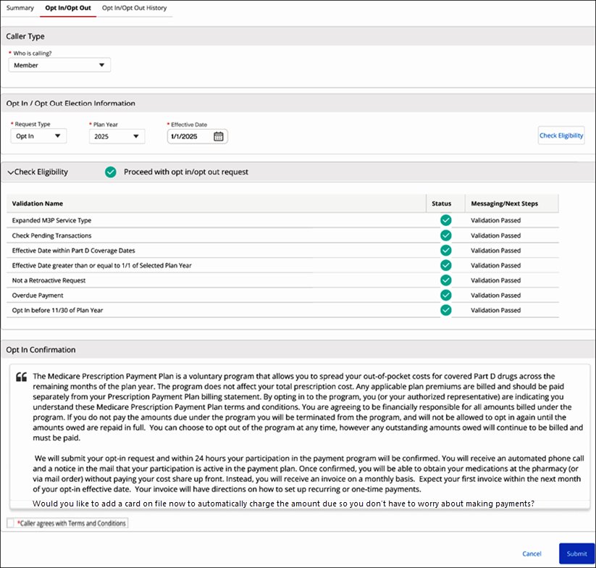

**Opt In Request Type Section/Field Descriptions:**

|  |  |
| --- | --- |
| **Section / Field** | **Details** |
| **Caller Type** | * **Who is calling?** drop-down menu.   + The **Who is calling?** field will pre-populate based on the authentication process. * Additional fields will populate depending on who is calling. |
| **Opt In / Opt Out Election Information** | * **Request Type:** Opt In * **Plan Year** * **Effective Date:** Input date to begin the Medicare Prescription Payment Plan.   + Date will prepopulate to 1/1 of the selected **Plan Year** or the current date, whichever is greater. * **Check Eligibility button:** Will only be enabled after all required fields in the **Opt In / Opt Out Election Information** section are completed. |
| **Check Eligibility** | This section will display Validations Passed/Failed when determining beneficiary’s eligibility for opting in to the Medicare Prescription Payment Plan.  **Note:** All Validations must be passed prior to proceeding with the Opt-In process. |
| **Opt In Confirmation** | * Read the provided Opt In Confirmation to the beneficiary. * Click the **Caller agrees with Terms and Conditions** checkbox when the beneficiary agrees with the Opt In Confirmation statement. |
| **Cancel Button** | Cancels the Opt In Request. |
| **Submit Button** | Submits the Opt In Request once all mandatory fields are completed. |

Top of the Section

### Opt Out Request Type

**Opt Out Request Type Example:**

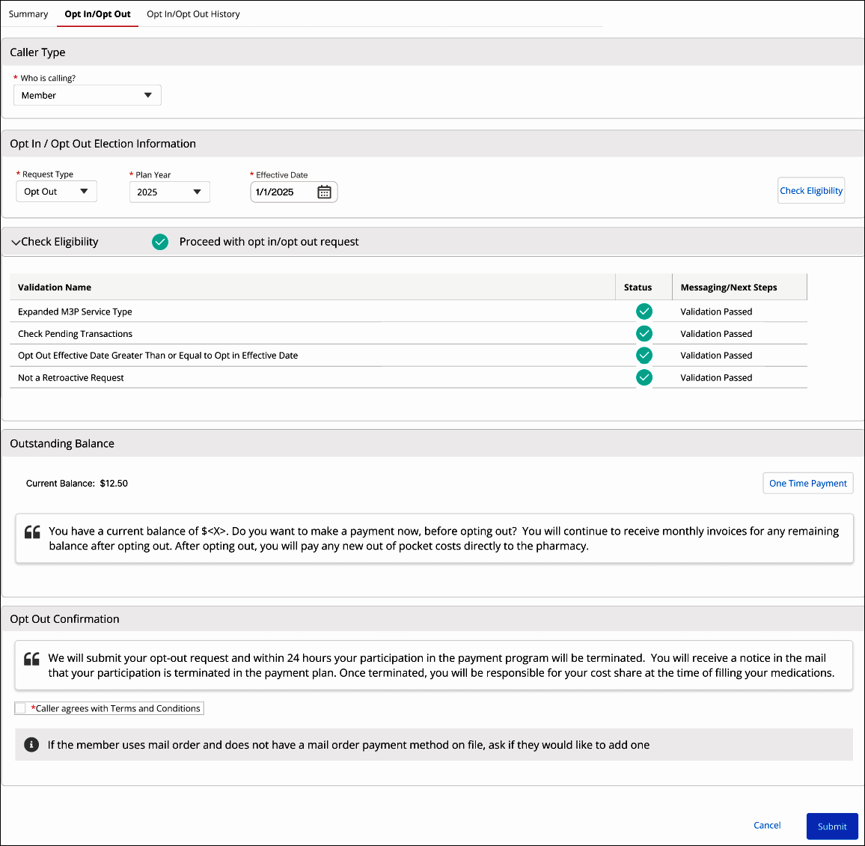

**Opt Out Request Type Section/Field Descriptions:**

|  |  |
| --- | --- |
| **Section / Field** | **Details** |
| **Caller Type** | * **Who is calling?** drop-down menu.   + The **Who is calling?** field will pre-populate based on the authentication process. * Additional fields will populate depending on who is calling. |
| **Opt In / Opt Out Election Information** | * **Request Type:** Opt Out * **Plan Year** * **Effective Date:** Input date to opt out of the Medicare Prescription Payment Plan.   + Date will prepopulate to 1/1 of the selected **Plan Year** or the current date, whichever is greater. * **Check Eligibility button:** Will only be enabled after all required fields in in the **Opt In / Opt Out Election Information** section are completed. |
| **Check Eligibility** | This section will display Validations Passed/Failed when determining beneficiary’s eligibility for opting out of the Medicare Prescription Payment Plan.  **Note:** All Validations must be passed prior to proceeding with the opt out process. |
| **Outstanding Balance** | * **Current Balance** * **Suggested verbiage:** “You have a current balance of $<X>. Do you want to make a payment now, before opting out? You will continue to receive monthly invoices for any remaining balance after opting out. After opting out, you will pay any new out of pocket costs directly to the pharmacy.”   **Note:** If the beneficiary does not have an outstanding balance, the talk track and **One Time Payment** button will not display. |
| **Opt Out Confirmation** | * Read the provided Opt Out Confirmation to the beneficiary. * Click **Caller agrees with Terms and Conditions** checkbox when the beneficiary agrees with the above statement. |
| **Cancel Button** | * Cancels the Opt Out Request. |
| **Submit Button** | * Submits the Opt Out Request once all mandatory fields are completed. |

Top of the Document

|  |
| --- |
| Opt In/Opt Out History Tab |

The **Opt In/Opt Out History** tab displays Transactions for the selected **Plan Year**.

* The **Opt In/Opt Out History – All Transactions** section displays a record of each time a beneficiary has requested to opt in/opt out of the Medicare Prescription Payment Plan. It includes Confirmed Transactions and Pending Transactions.
  + The **All Transactions** information icon () displays the following message: “This list includes pending and confirmed transactions. Pending transactions are Opt-In/Opt-Out requests waiting for plan approval.”
* The **Opt In/Opt** **Out History** **– Confirmed Transactions** section displays a record of each time a beneficiary has opted in or opted out of the Medicare Prescription Payment Plan.
  + **Confirmed Transaction:** An Opt-In/Opt-Out submission that has been completed.
    - **Note:** An Opt-In/Opt-Out submission must be confirmed for claims to process with the Medicare Prescription Payment Plan benefit.

**Note:**

* “No records found” will display when there is no Opt In/Opt Out history.
* If **Activity** is “Not Participating” then the beneficiary opted-out of the program on or before their Opt-In **Effective Start Date**.
* To confirm if an Opt-In request has been processed, refer to the **Verification of Opt-In Processing** section of [Compass MED D – Opt-In Process for Medicare Prescription Payment Plan.](https://thesource.cvshealth.com/nuxeo/thesource/#!/view?docid=55182d9e-d465-4f33-9b83-b3132110c86b)

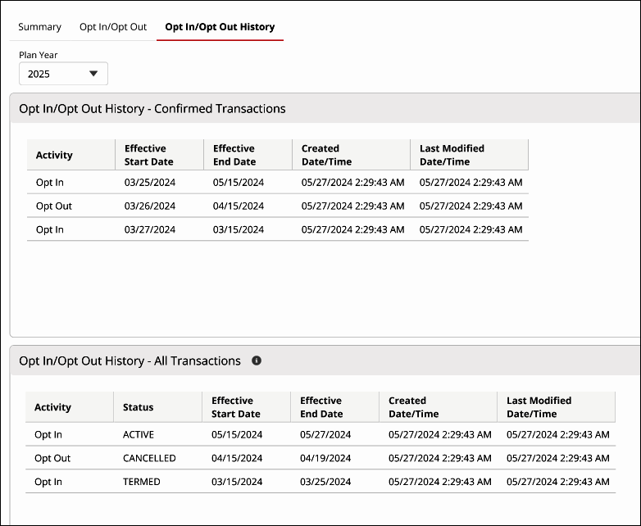

Top of the Document

|  |
| --- |
| Payment Schedule & Forecast Tab |

The **Payment Schedule & Forecast** tab displays the member’s current monthly payment amounts and the **Forecast** tool.

**Note:** The **Forecast** section tool may be used to show estimated future payment amounts when additional prescriptions are added to the Medicare Prescription Payment Plan. Refer to the **“Viewing Payment Schedule and Estimating Future Payment Amounts (Forecast)”** section in [Compass MED D – Billing, Payments, & Forecasting - Medicare Prescription Payment Plan](https://thesource.cvshealth.com/nuxeo/thesource/#!/view?docid=955acdc4-aa21-499b-8481-41a58f44cc20) for additional information.

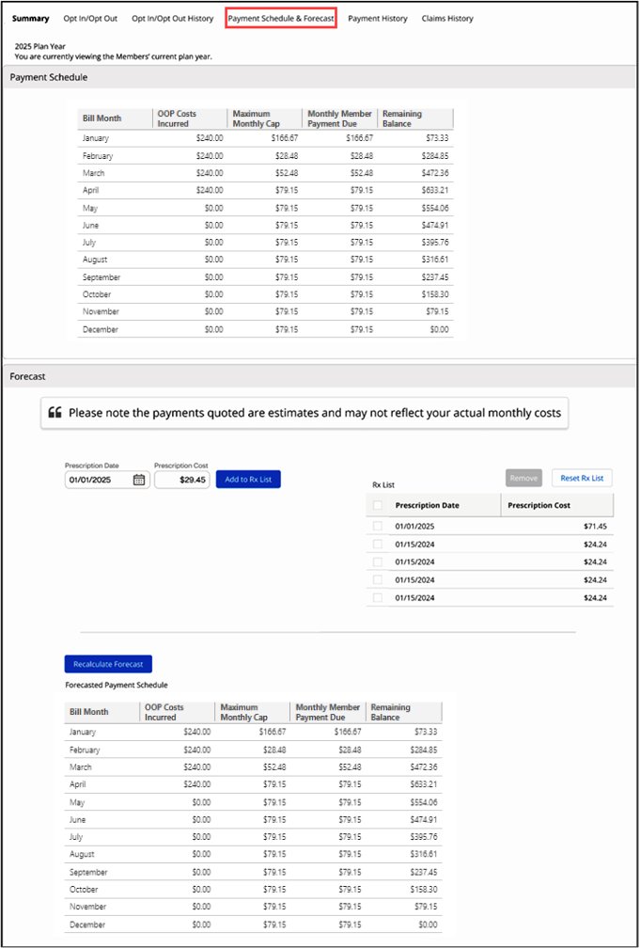

|  |  |  |
| --- | --- | --- |
| **Sections** | **Tools** | **Description** |
| **Payment Schedule** | **N/A** | Displays a view of the Current Plan Year Payment Schedule. |
| **Forecast**  Forecast Medicare Prescription Payment Plan billing payments by entering the required information into the **Prescription Date** and **Prescription Cost** fields.  You can **ONLY** enter prescription dates within the Plan Year displayed at the top of the Payment Schedule & Forecasttab. | **Add to Rx List** button | Used to Add dates and costs to the Rx List. User can then view the added prescription costs and dates in the Rx List. |
| **Remove** button | Used to individually select and removeadded prescription dates and prescription costs previously added to the Rx List. |
| **Reset Rx List** button | Used to remove all prescriptions and costs previously added to the Rx List (the table will also be removed from the screen if a reset is done).  **Note:** User can recalculate estimated monthly payment amounts based on the removed prescription costs and dates. |
| **Check Boxes** | Display to the left of the Rx List and are selected when the prescription date and prescription cost need removed. |
| **Recalculate Forecast** button | Used to recalculate estimated monthly payment amounts based on the added/removed prescription costs and dates from the Rx List. Once recalculated, the revised forecasted monthly payments will display in the **Forecasted Payment Schedule** table. |

Top of the Document

|  |
| --- |
| Payment History Tab |

The **Payment History** table displays Medicare Prescription Payment Plan payment history details:

* Invoice Number
* Invoice Amount
* Bill Due Date
* Payment Date
* Paid Amount
* Applied Amount
* Payment Type
* Payment Source
* Payment Channel
* Payment Status

**Notes:**

* If there is no payment history available, the following message displays: “No records found.”
* When hovering over the **Refresh** button, “Refresh Payment History” displays.

Below the **Payment History** table, the **Credit and Refund History** table displays Medicare Prescription Payment Plan credit and refund details:

* Payment Type
* Adjustment Amount
* Invoice #
* Payment Date

Top of the Document

|  |
| --- |
| Claims History Tab |

The **Claims History** tab displays all claims processed through the Medicare Prescription Payment Plan for the selected plan year. Each listed claim will include the following information:

* Fill Date
* RX # - Clicking the hyperlink will open the **Claims Details** tab for the claim.
* Drug Name/Strength
* Mbr Pay - Clicking the hyperlink will open the **Financial Details** tab for the claim.
* Status

For more detailed information about one of the listed claims, you must navigate to the Claims Landing Page.

**Notes:**

* Claims processed prior to the member opting in to the Medicare Prescription Payment Plan will not display on this tab.
* Claims processed after the member has reached their Maximum Out of Pocket (MOOP) will not process through the Medicare Prescription Payment Plan, and so will not display on this tab.

Top of the Document

|  |
| --- |
| Related Documents |

[Compass MED D – Medicare Prescription Payment Plan Guidelines](https://thesource.cvshealth.com/nuxeo/thesource/#!/view?docid=54f362a8-c10b-43c3-b4dd-124af1173532)

**Abbreviations/Definitions:** [Customer Care Abbreviations, Definitions, and Terms Index](https://thesource.cvshealth.com/nuxeo/thesource/#!/view?docid=c1f1028b-e42c-4b4f-a4cf-cc0b42c91606)

**Parent Document:** CALL-0048:[Medicare Part D Customer Care Call Center Requirements-CVS Caremark Part D Services, L.L.C.](https://policy.corp.cvscaremark.com/pnp/faces/DocRenderer?documentId=CALL-0048)

Top of the Document

Not To Be Reproduced Or Disclosed to Others Without Prior Written Approval

**ELECTRONIC DATA = OFFICIAL VERSION / PAPER COPY = INFORMATIONAL ONLY**